Candoris weekly update provided by Martijn van Vliet:
As of April 22, 2025 for professional investors only
- Macro Economy/ Markets
- Strategies offered by Candoris
Click here to play the update
Scroll down for the charts used and weekly summary

* When pictures do not open in your outlook, click here to view them in PDF)
There are times when markets hang on every detail - the next CPI print, a single comma in the Fed’s minutes, or the latest Non-Farm Payroll figures.
We are not in one of those times now 😂
We’re in a world where a U.S. president publicly criticizes the Fed chair and may seek to replace him. A world where countries are being pushed to choose between the U.S. and China as trade partners. Where the U.S. could just as easily strike Iran as strike a deal. Where tariffs can double overnight or disappear entirely.
In this kind of world, it’s not the details that moves markets. It’s the big picture.
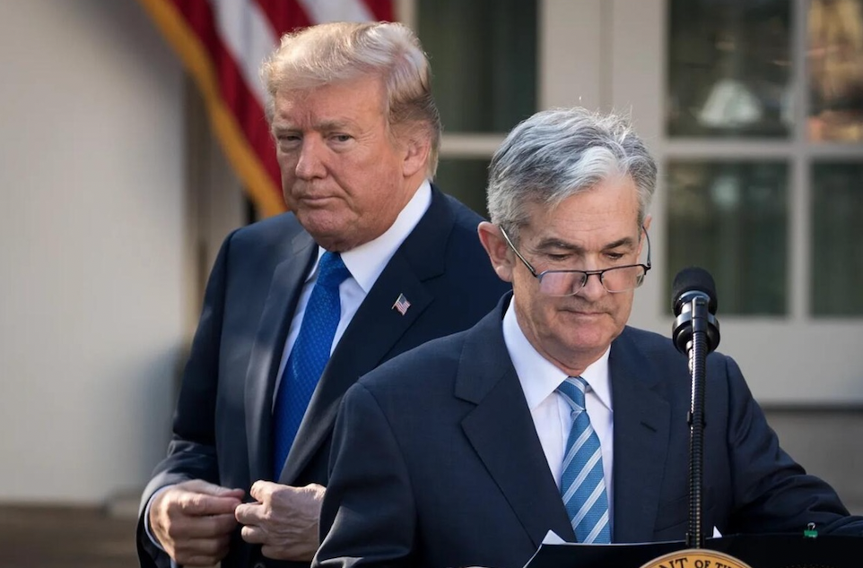

The big picture is that the flight to safety is no longer into US Government Bonds, or the USD, but out of it!
Yesterday was a classic China-dumping day: yields up, USD down smart timing in a market with low trade volumes.
Beijing buying gold, taking Trump's tweet quite literary : "THE GOLDEN RULE OF NEGOTIATING AND SUCCESS: HE WHO HAS THE GOLD MAKES THE RULES. THANK YOU!"
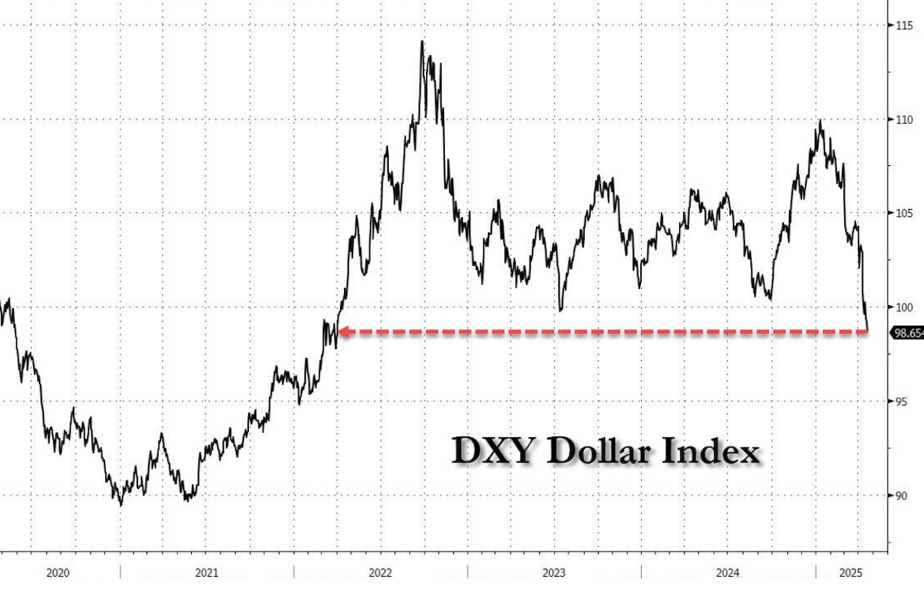
source: Bloomberg

Save heavens are GOLD, YEN, CHF, Euro..
With gold rising daily with 1-3%
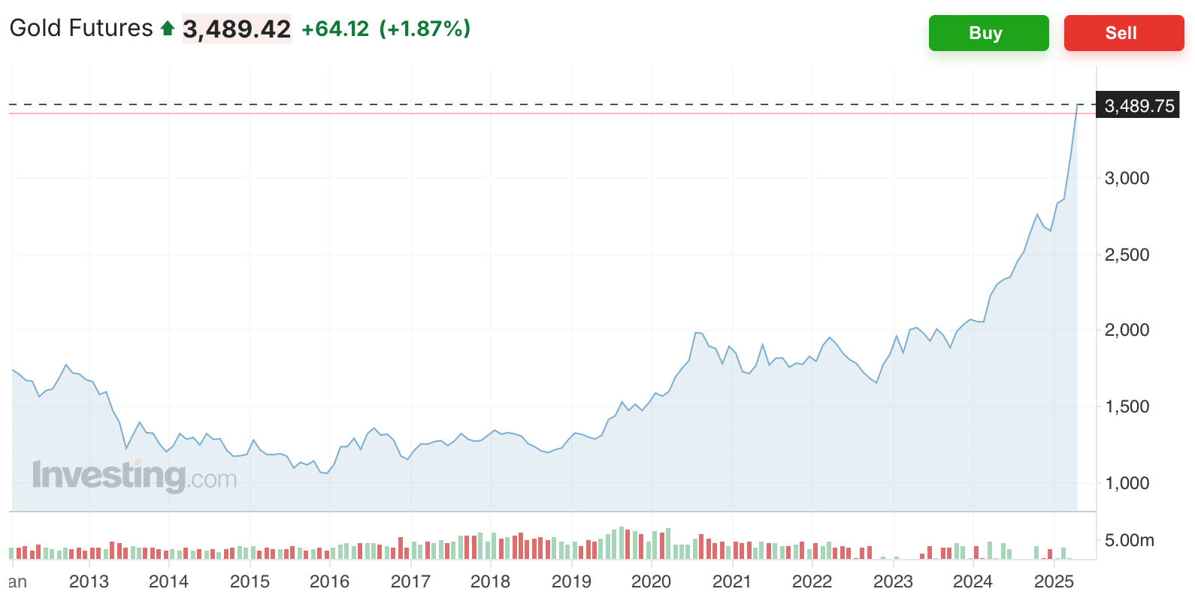

Gold by the way is now close to its all time INFLATION adjusted high
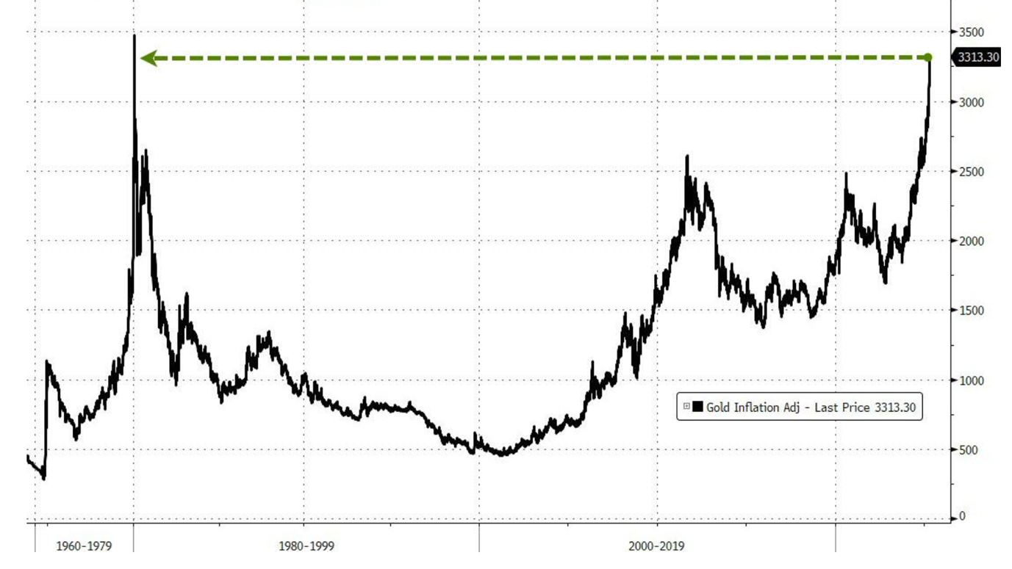
source: Bloomberg

In all fairness, things do not look good at all.
US sovereign risk is going up
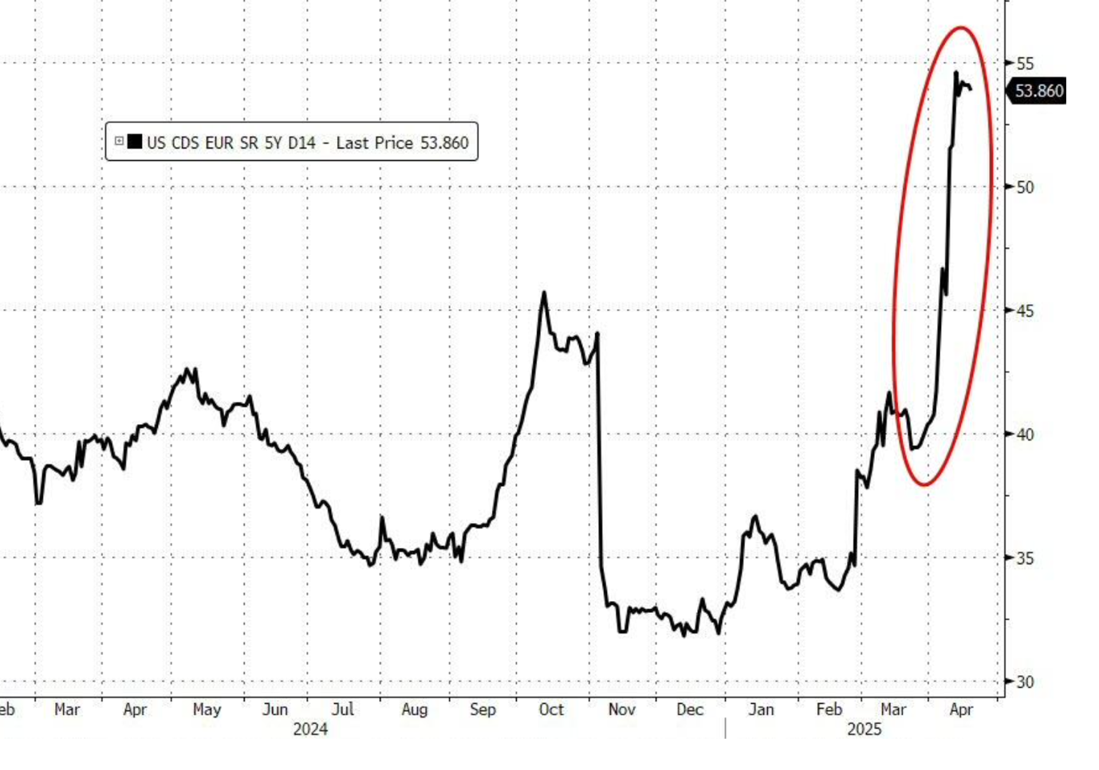
source: Bloomberg

And Trump is digging himself in
both related to the economic war with China as well as with FED chair Powell.
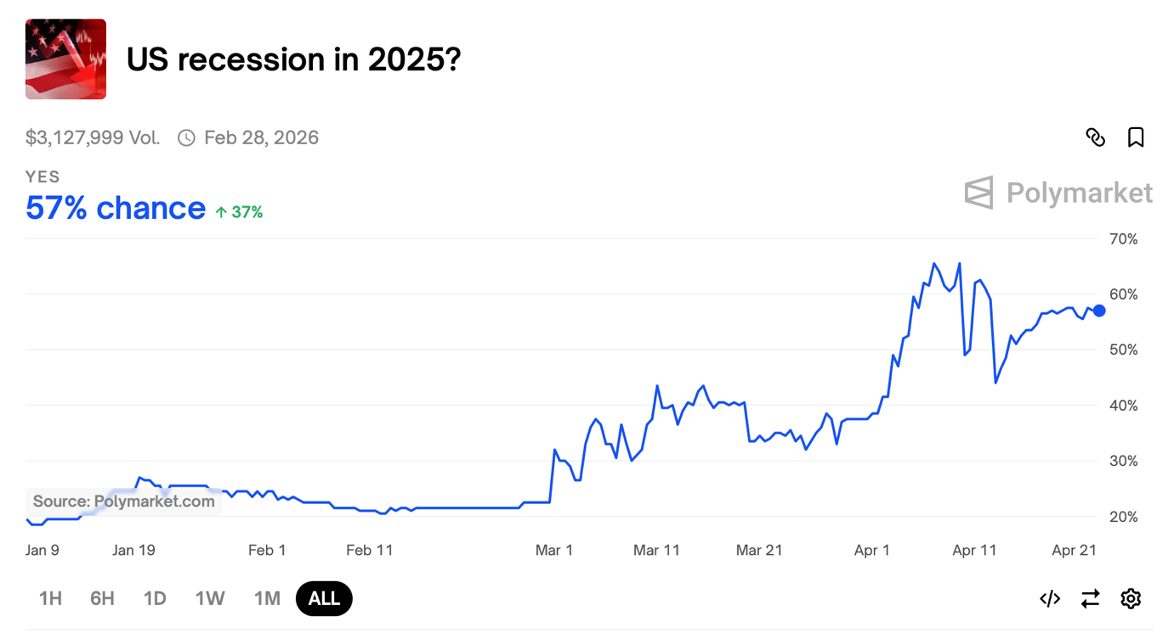

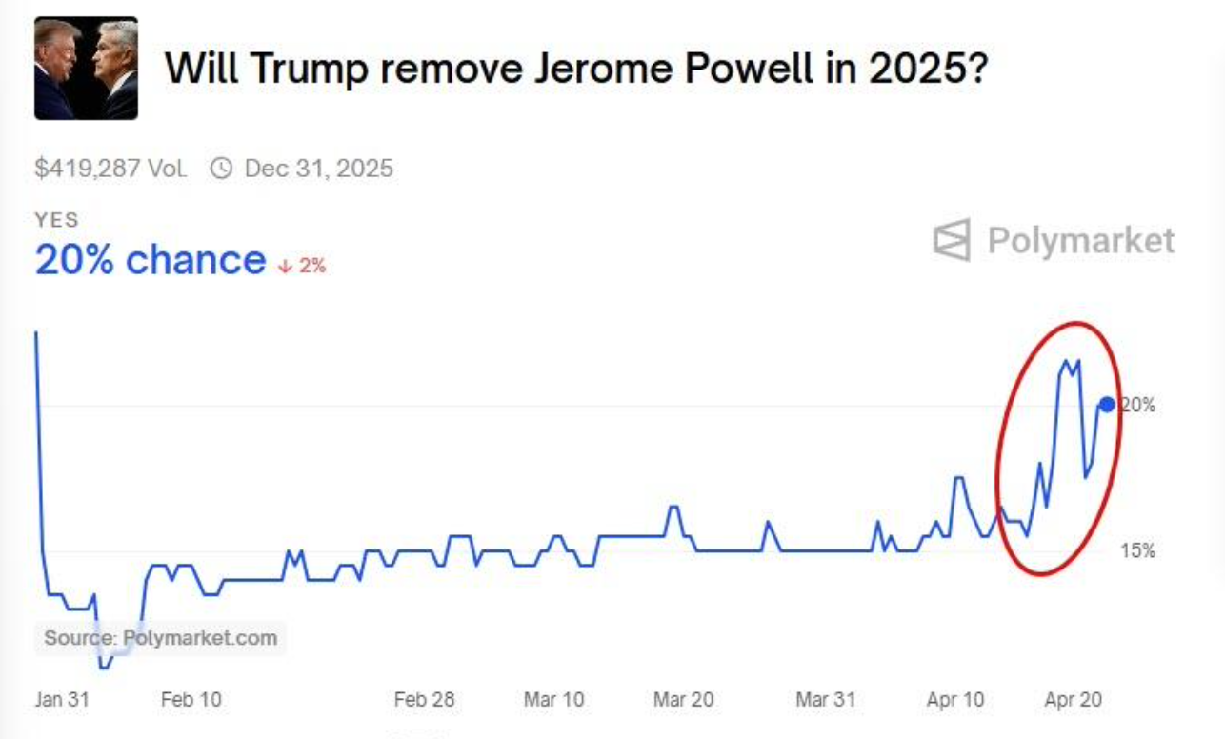

But as much as it seems risks are to the downside, risk could very well be to the upside.
"Markets stop panicking when central bank start panicking"
Rates in the US are rising rapidly, at some point the FED could step in via QE
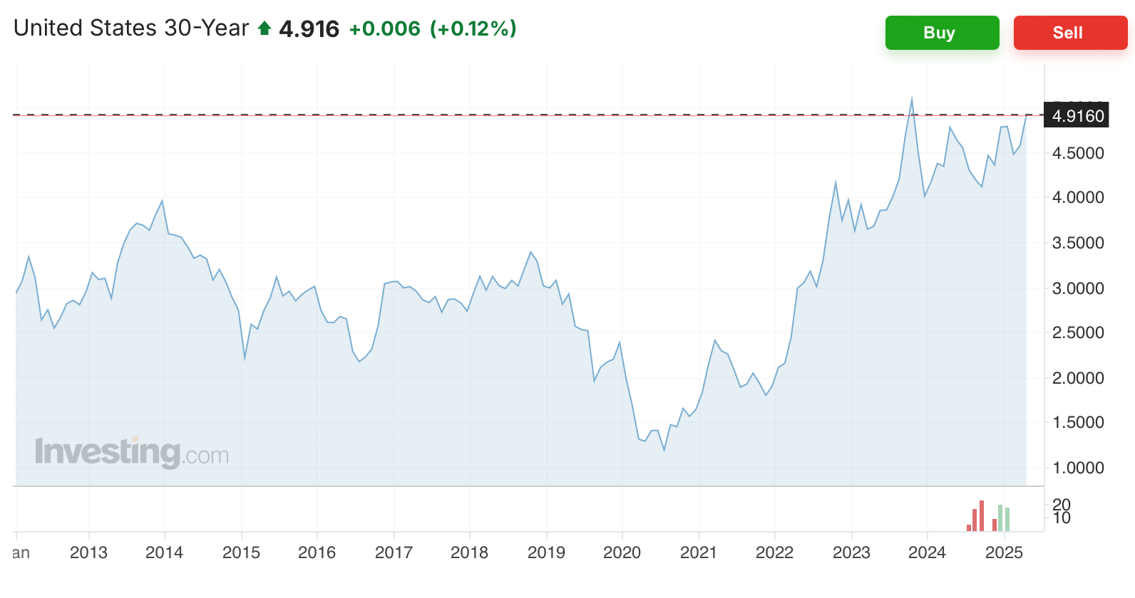

And SFOR Swap Spreads, a proxy for pain in the system are getting worse again.
- SFOR swap spreads can act as a barometer of pain, especially in fixed income plumbing.
- If they move too far, particularly due to illiquidity or dysfunction (not just macro views), the Fed is likely to intervene, as it has in prior episodes, to preserve market stability.
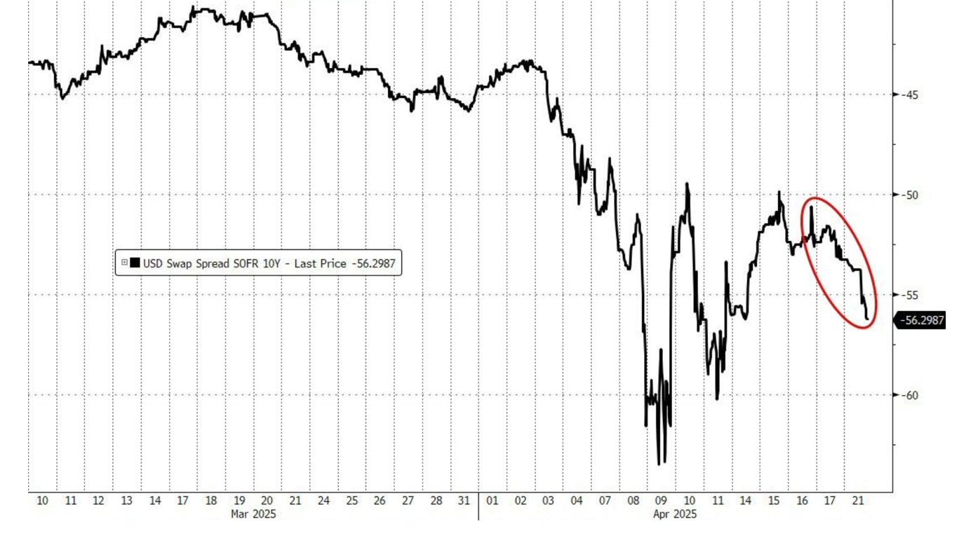
source: Bloomberg

Financial conditions are tight, all reasons for the FED to act.
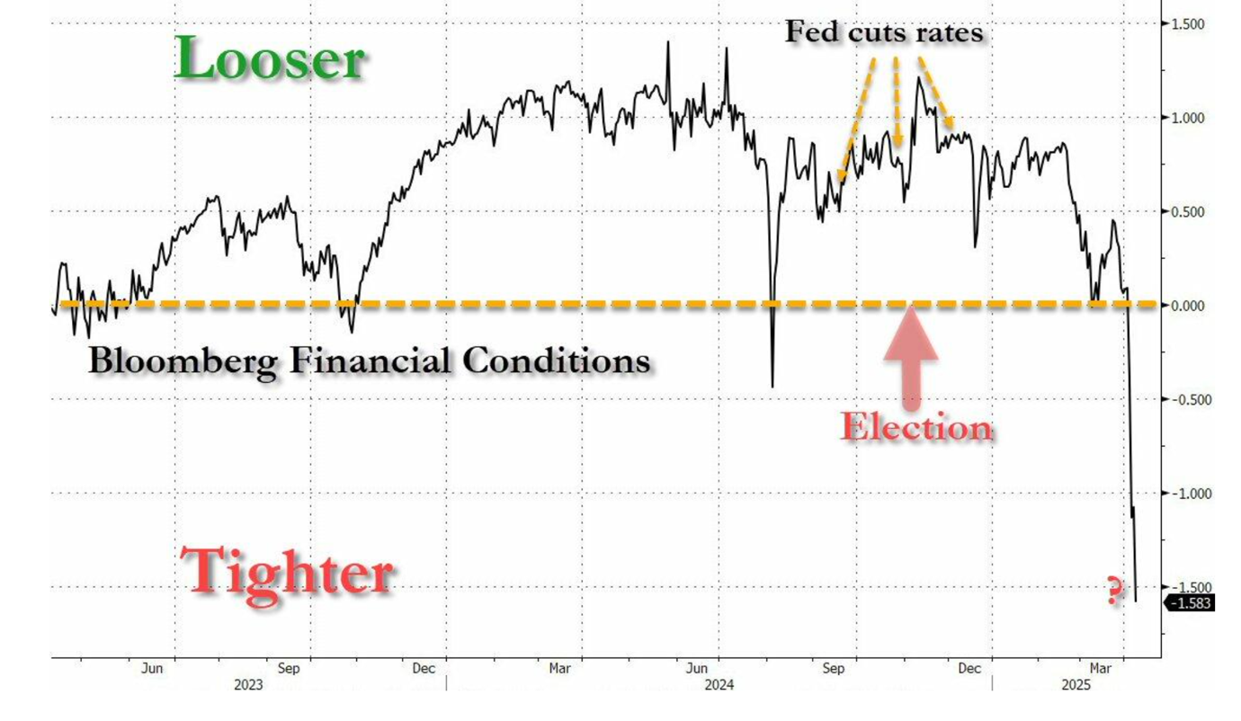
source: Bloomberg

There's a good chance either the market or the Republican Party will pressure Trump to dial things back—especially if the stress gets too intense and the midterms start looking shaky for re-election.
And even if it feels like a long shot, you can't totally rule out Trump striking a deal with China at some point.
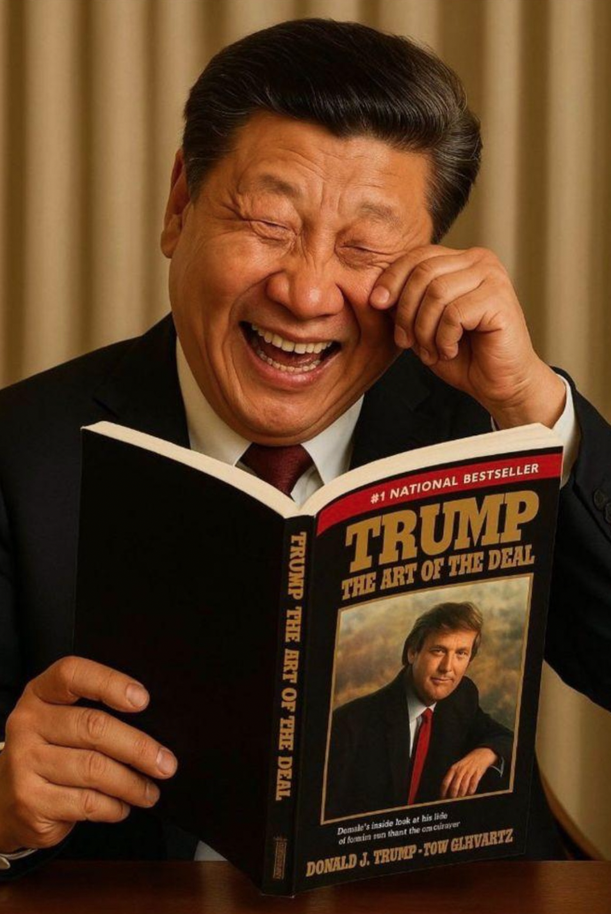

Meanwhile... a deflationary wave is coming to Europe.
Energy prices are down, The Chinese currency is down 10% and US Tariffs on China may lower global goods prices.
The imposition of high tariffs by the US on Chinese imports is expected to reduce global goods prices. While this move could be inflationary for the US, it is anticipated to have a deflationary impact on Europe
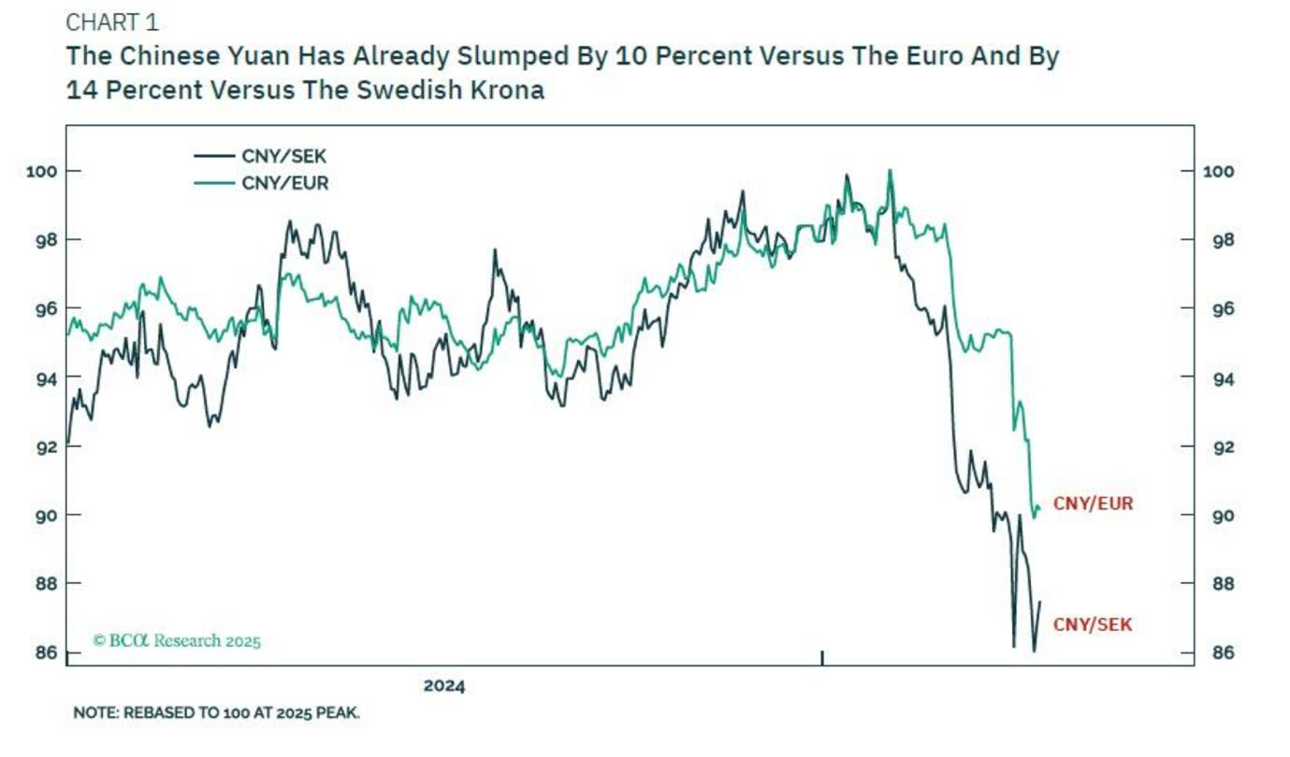

Moving to the markets:
Yesterday was bad for the main US indices. Small Caps were best.
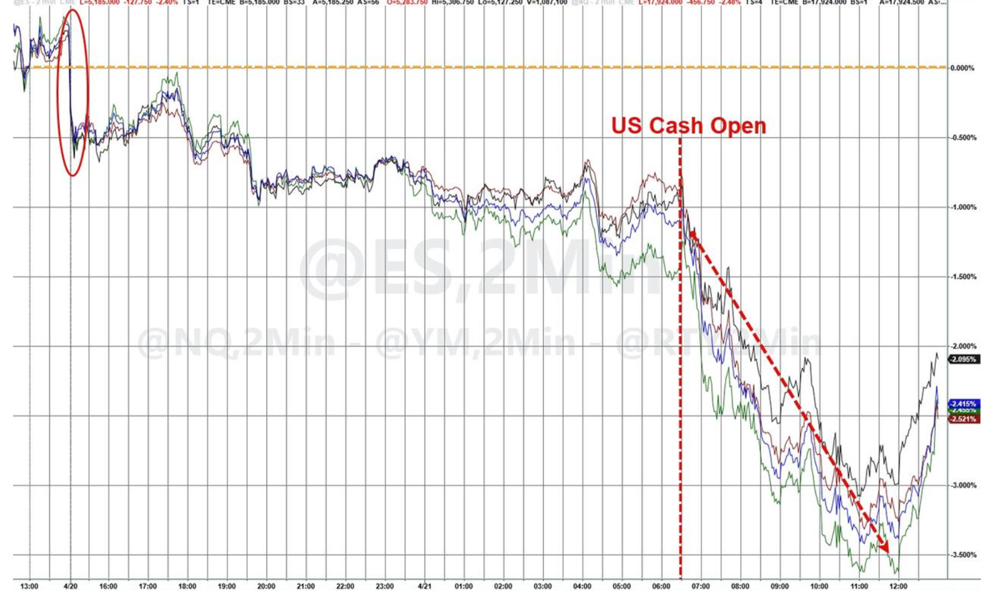
source: Bloomberg

Last week was a good week for US Small Caps, up >1%. All other US indices were down -1.1 to -2.4%
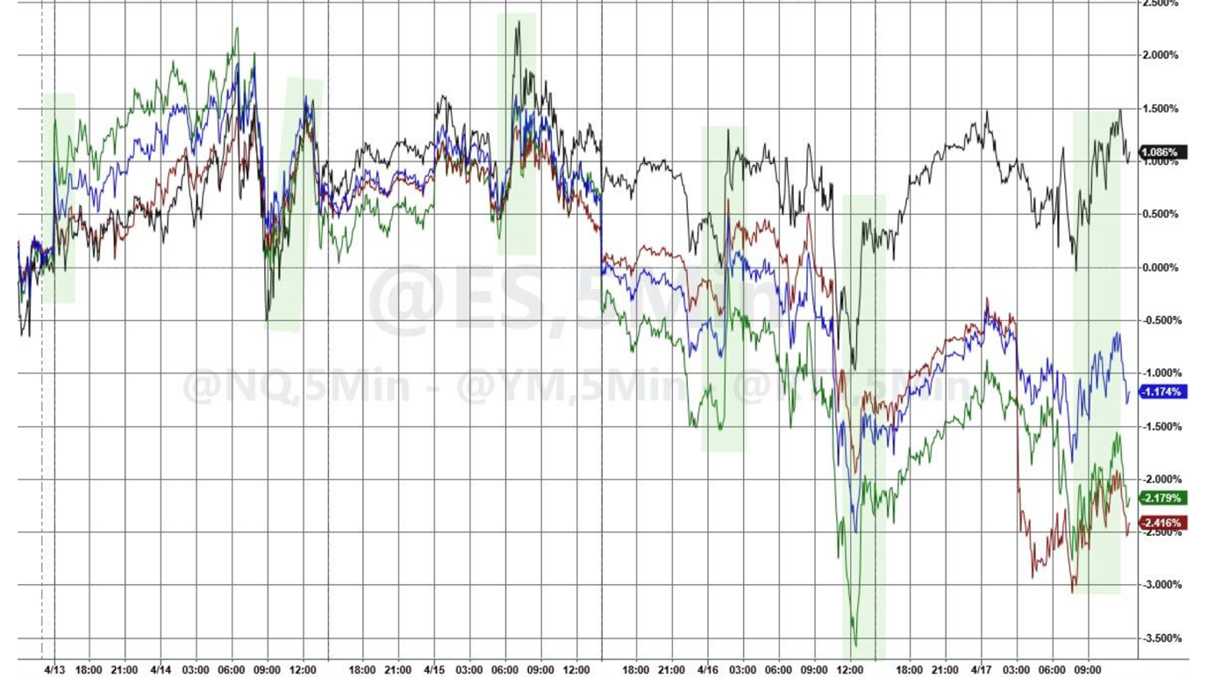
source: Bloomberg

Since Liberation day markets are down 7-8%
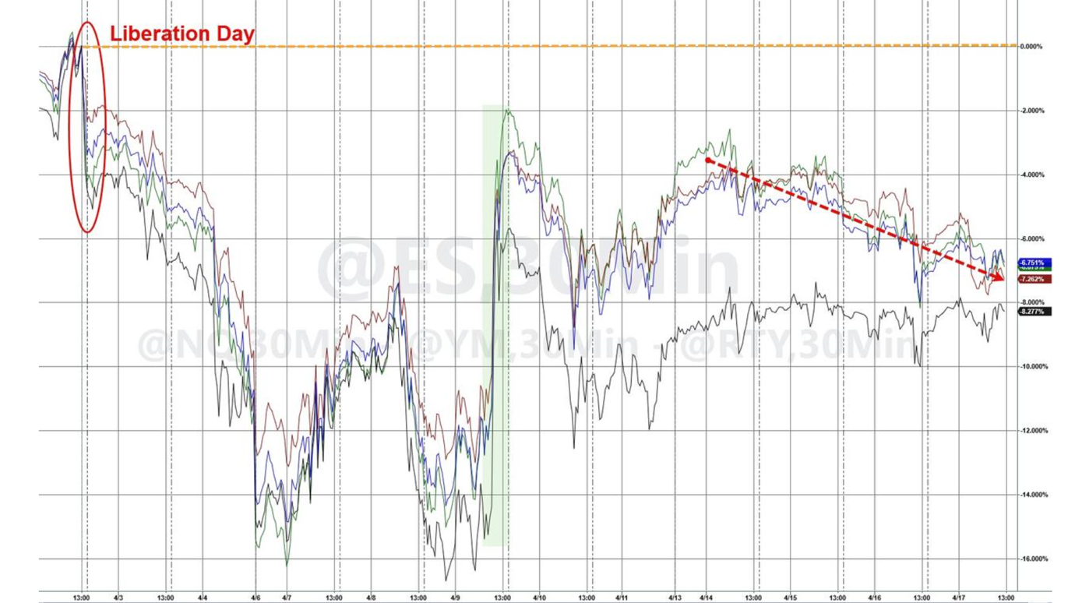
source: Bloomberg

The market has priced in 4 cuts now for 2025
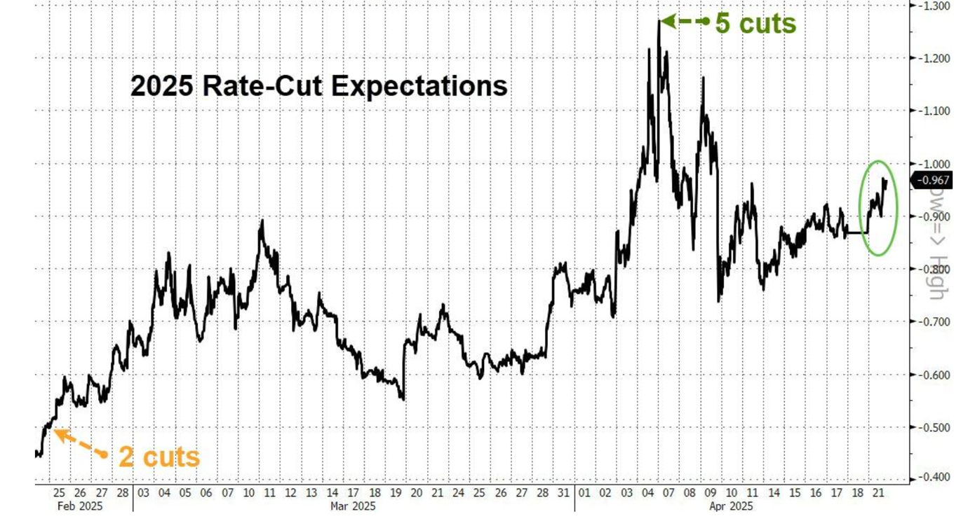
source: Bloomberg

US Small Caps were dumped in March, we got some of those outflows as well, higher Beta and US, but also strange in a way as they are more shielded from Tariffs as supply chains are less international
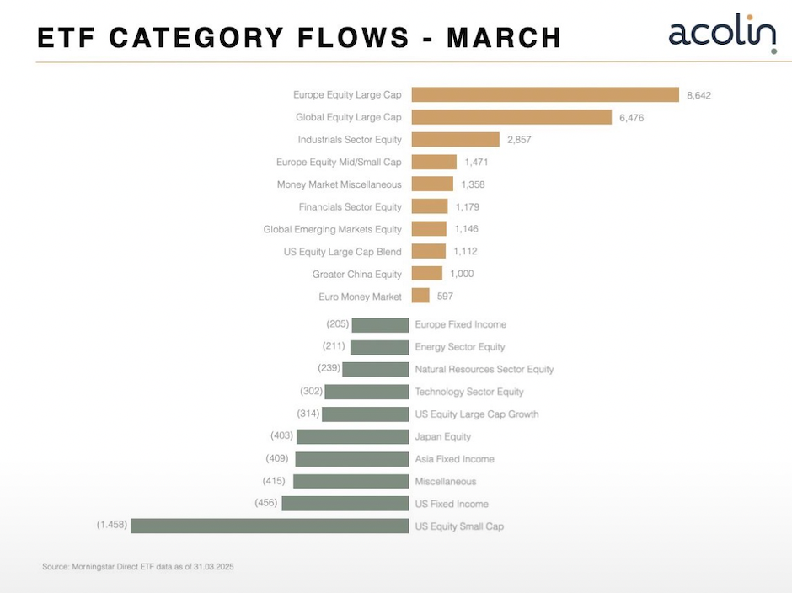

Poor guy had to listen to all that bullshit in one of his last days...
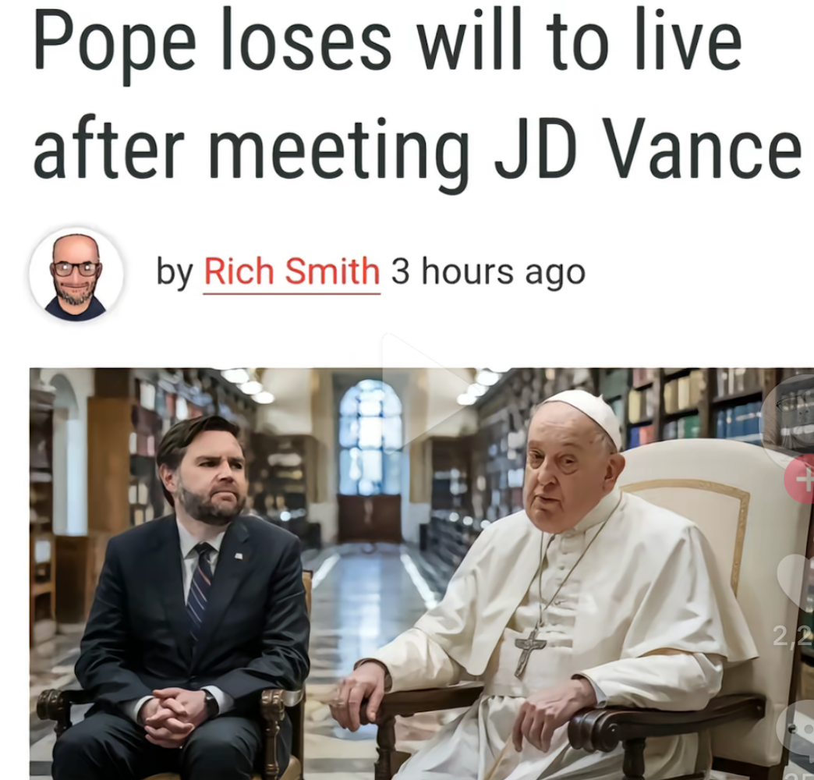

Macro data the week ahead:
relatively quiet, but with company earnings...
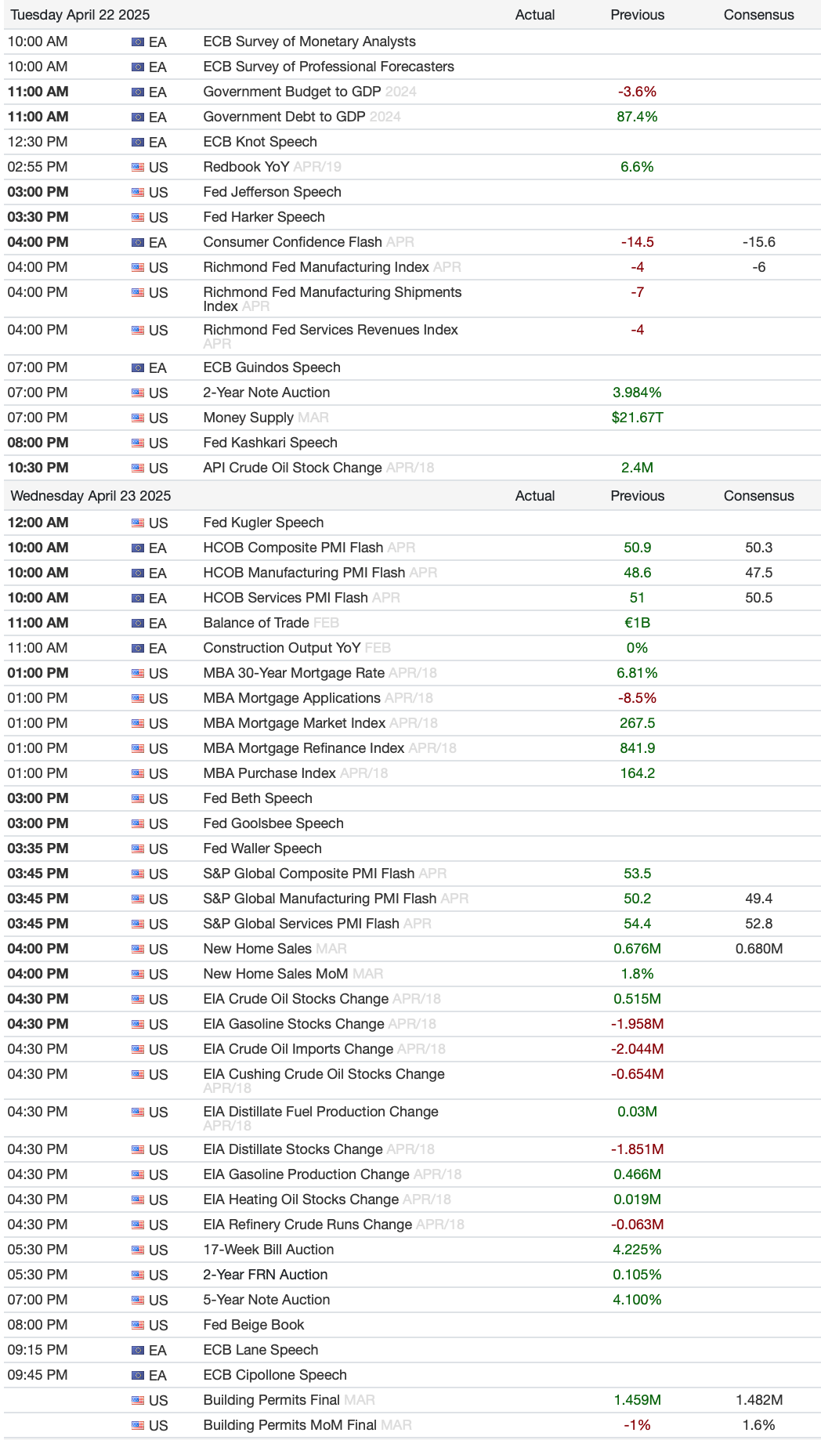
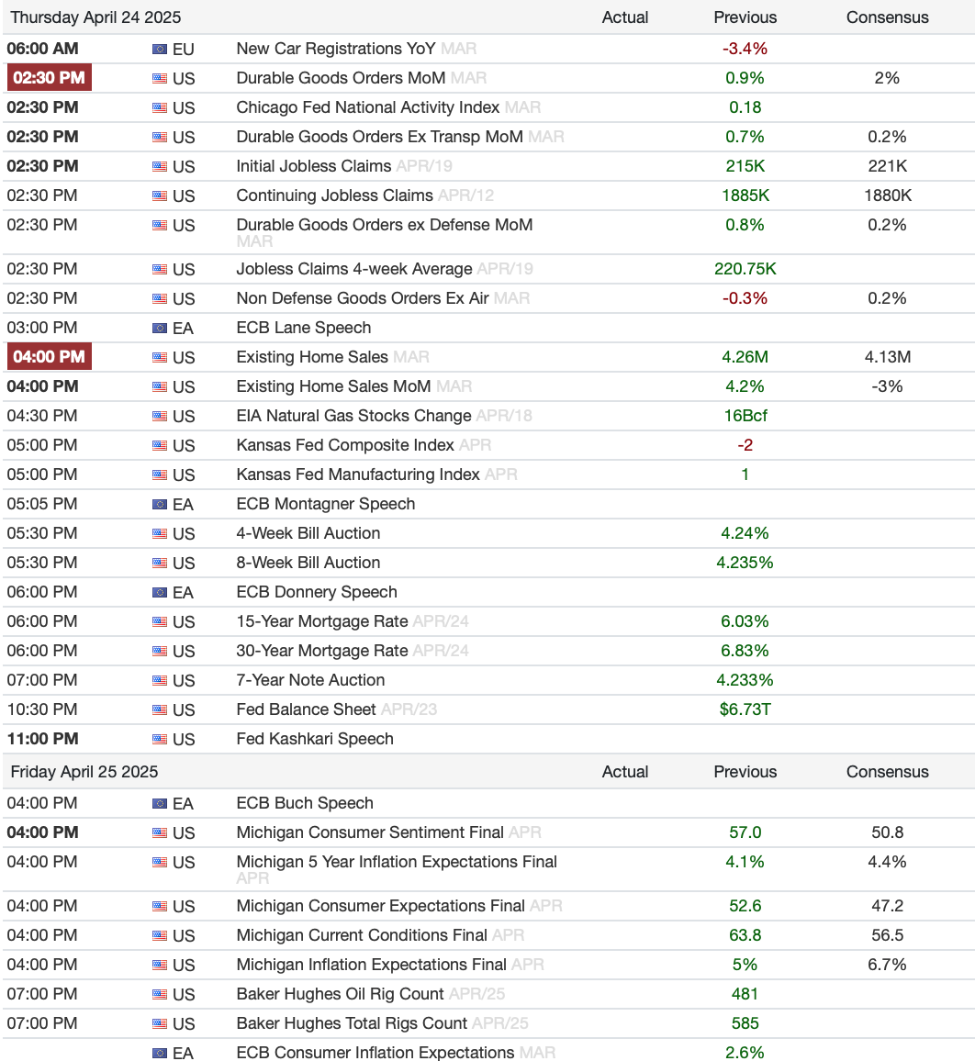

Candoris strategies
Let's go LETKO!

8% outperformance YtD
Letko EME versus i-Shares MSCI EM YtD
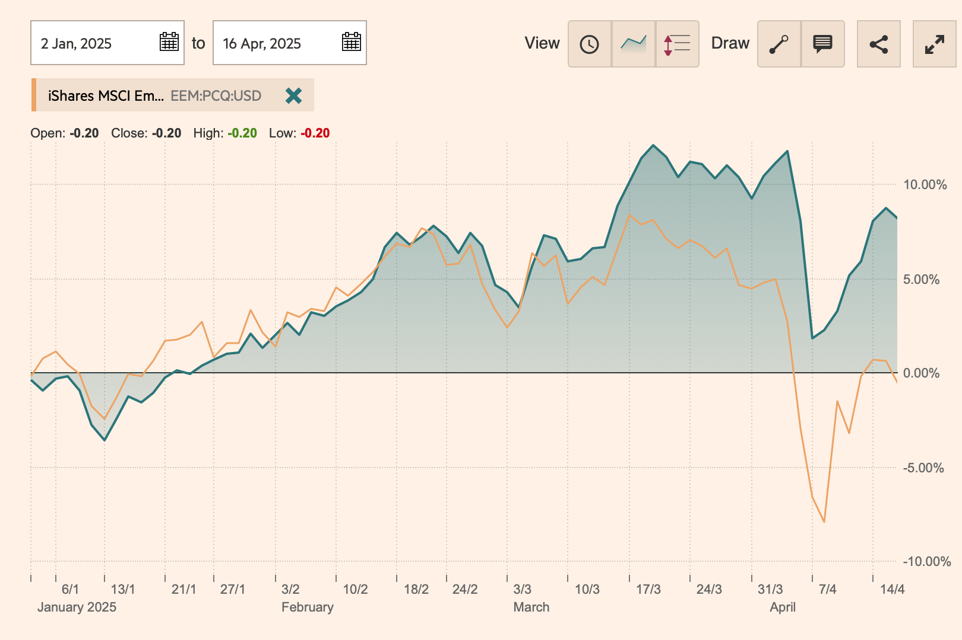
source: FT

10y return Letko Brosseau versus benchmark and peers till 31-03-2025
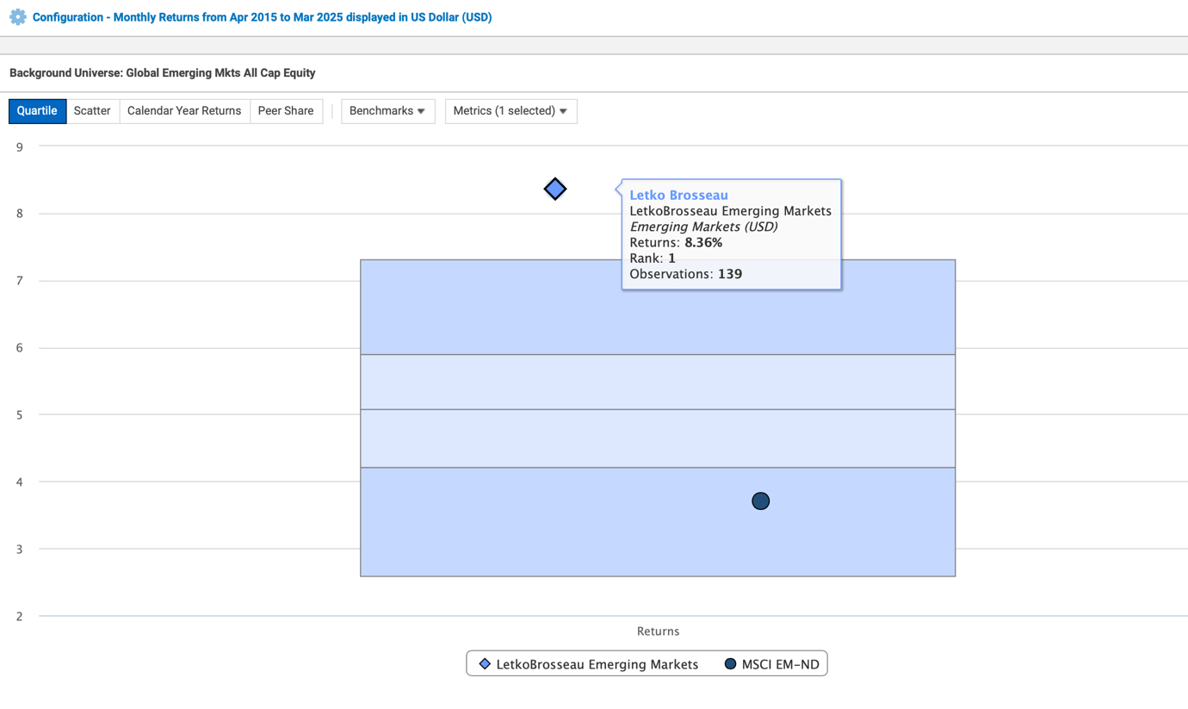

5 reasons why to invest with Letko and not with another EME manager:
- Consistent Outperformance: Letko Brosseau's EME strategy outperformed the benchmark by an annualized 4.65% over the last 10 years, outperforming all EME all-cap managers. The strategy has never underperformed the benchmark during years when the MSCI EM benchmark posted negative returns.
- Comprehensive Company Coverage: Letko looks at all 6000 listed EM companies instead of the 1500 in the benchmark and has an overweight in mid- and small-cap value stocks, which are often overlooked by other Asset Managers, but have historically provided strong performance in emerging markets.
- Distinct Sector and Country Allocation: The strategy's sector and country allocations are significantly different from benchmarks and peers. There is almost no overlap between the strategy's top 10 holdings and those of benchmarks or peers.
- Long-Term, Differentiated Strategy: The portfolio has a low turnover (below 20%) and a high active share (over 93%), reflecting a patient and distinct investment approach that aims for higher alpha.
- Competitive Fees: Letko Brosseau offers a favorable fee structure
- Why EME, Why now, Why Letko? Click here for the presentation

The Coho ESG Value strategy
Below an indication of the performance of the Coho fund (attribution based, not NAV based)
Hence almost 8% outperf. YtD versus the S&P 500
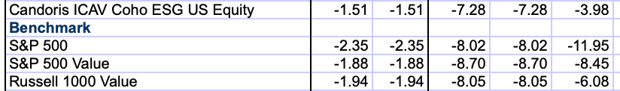

Drawdown of Coho in green is far less than those of the R1000V, S&P, R1000G
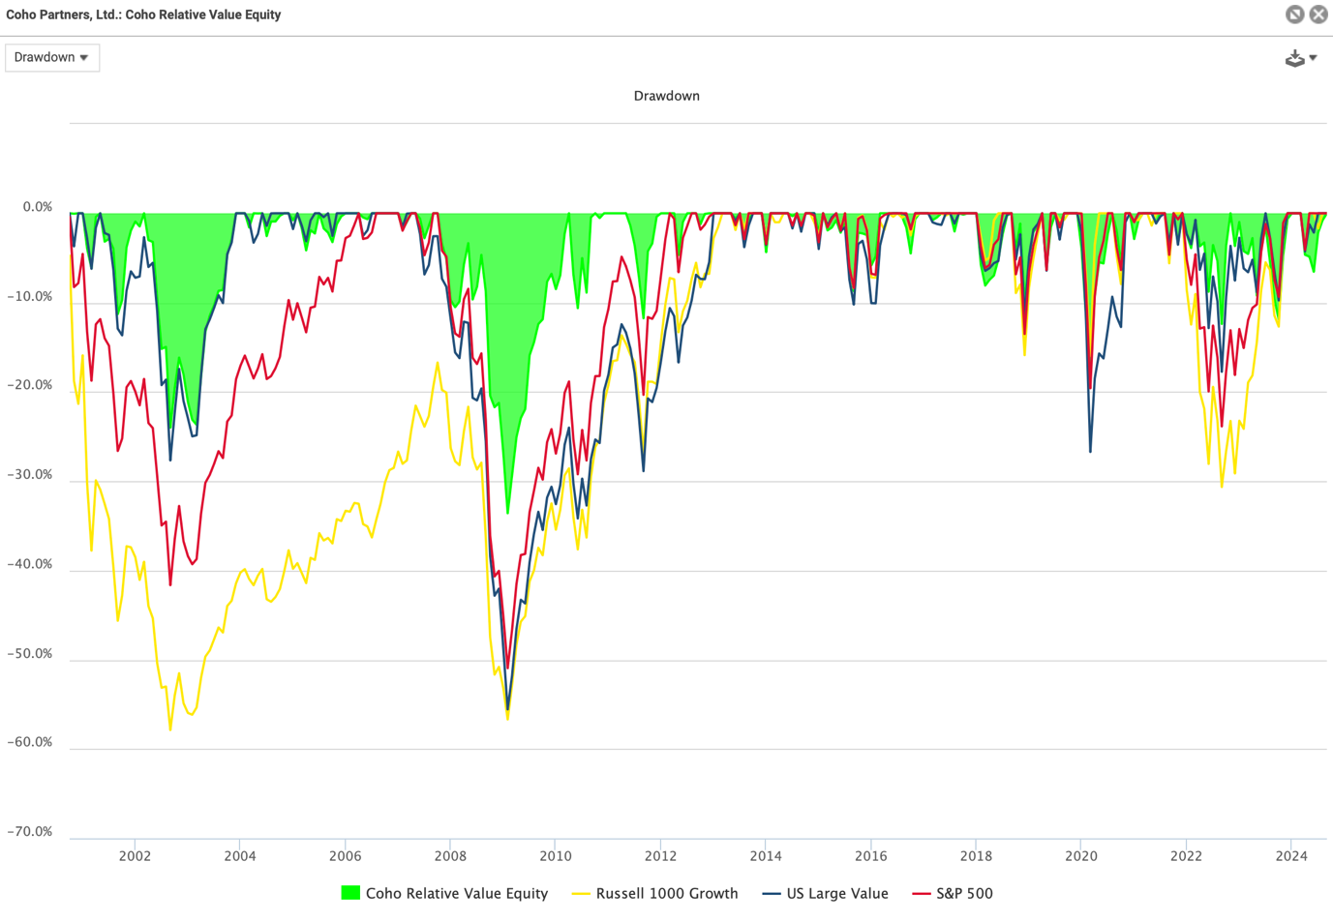
source: eVestment

SiM HY
Last 6m SiM (green) versus US HY peer category (orange)
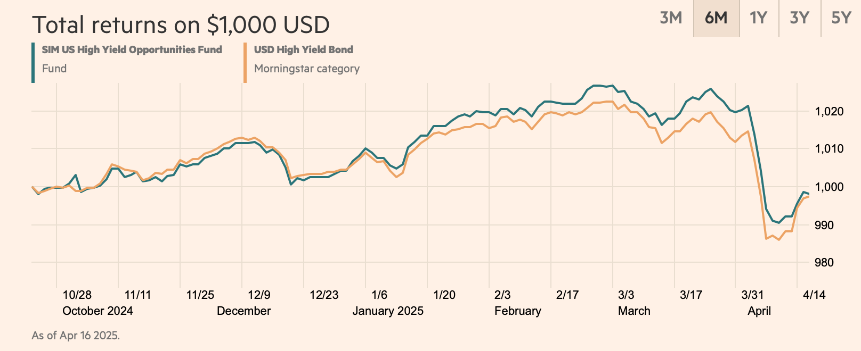
source: FT

SiM Beats ALL peers since inception!
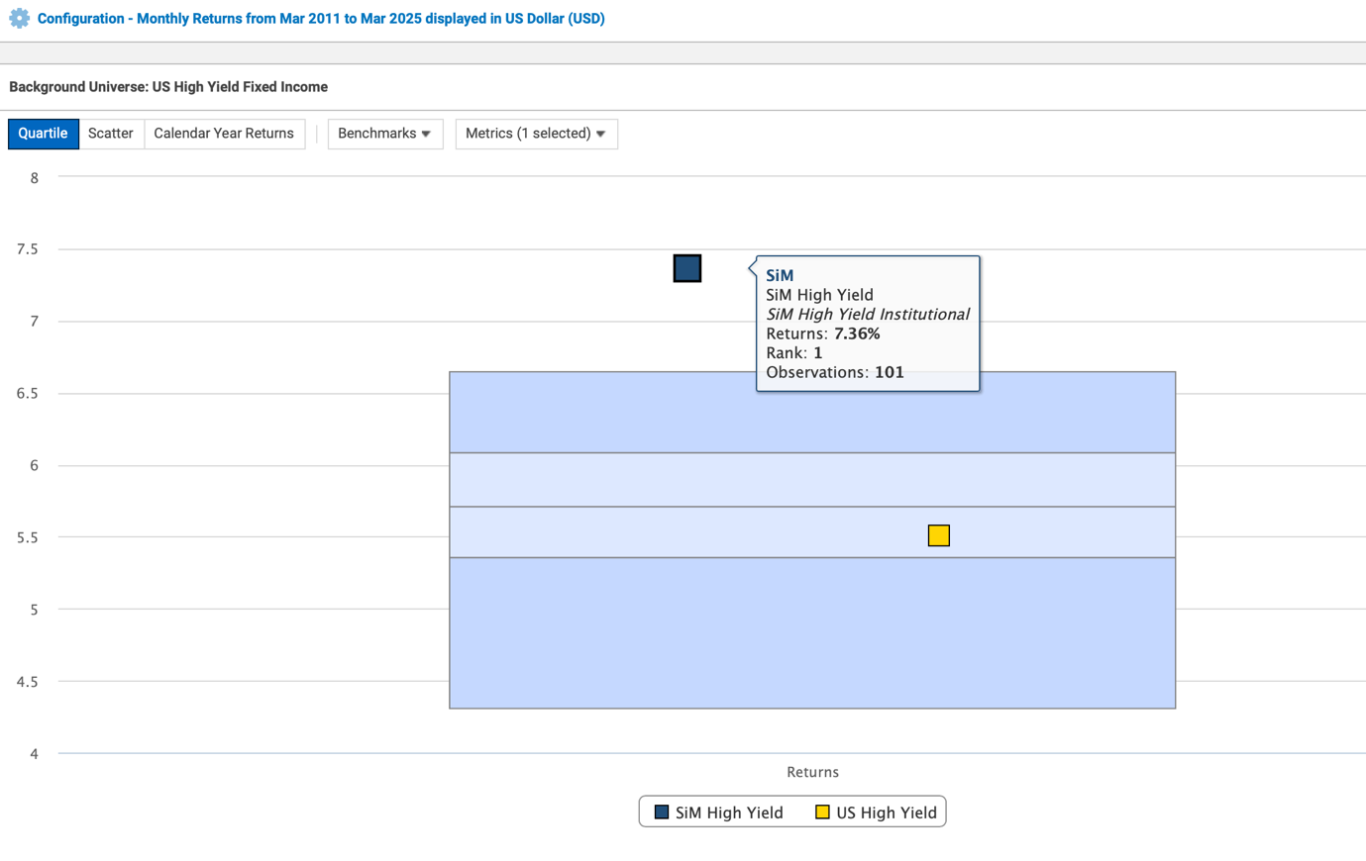

Performance v. Peers till end of March -> The chart every asset manager dreams off having.. 😁
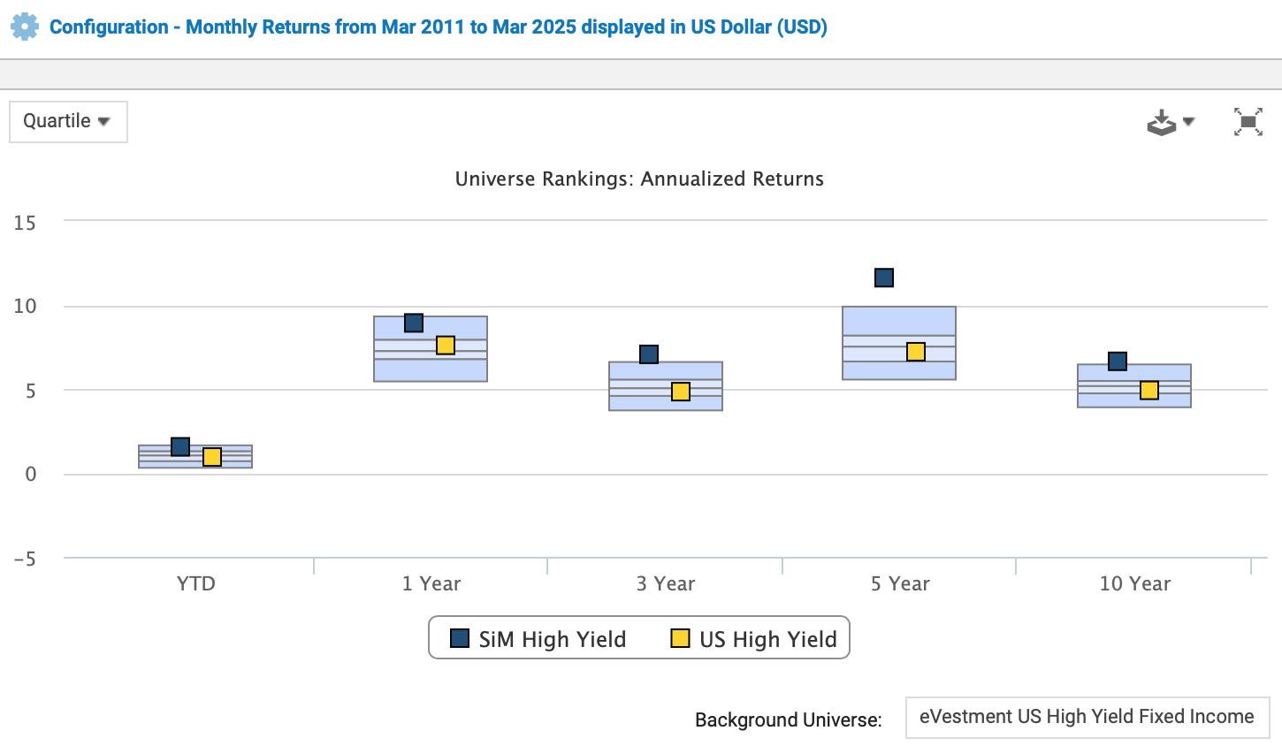

Next Century Growth US Small Cap Growth Equities
after 4.2% outperformance in 2024, YtD again ahead: performance NCG US Small Cap Growth (green) art. 8 UCITS fund versus iShares Russell 2000 Growth:
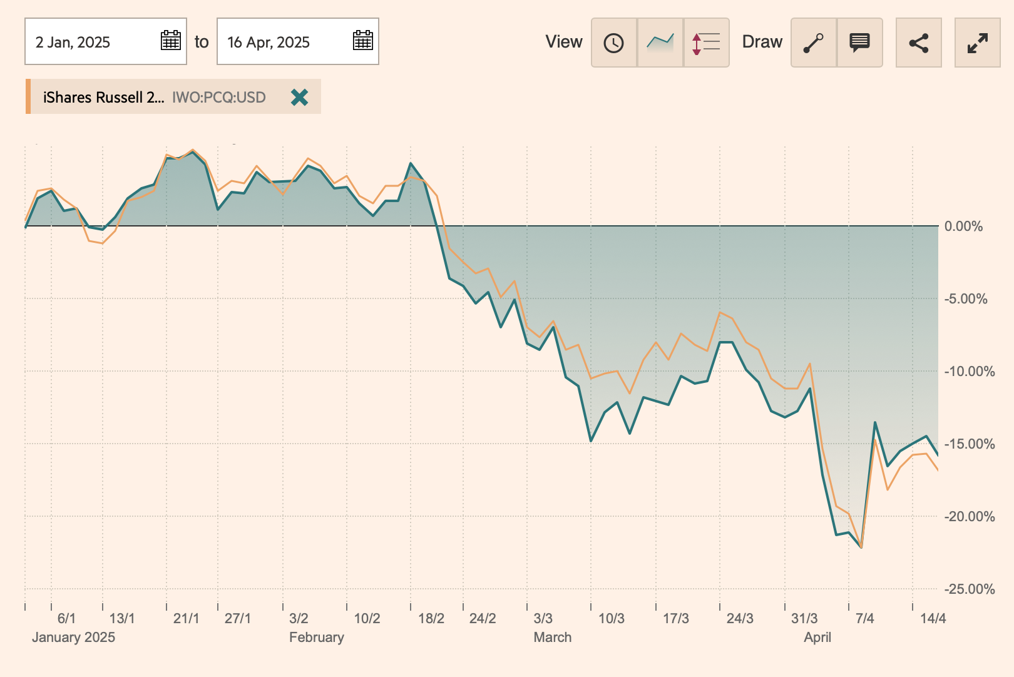
source: FT

NCG beating biggest US Small Cap Growth peers YtD: versus Driehaus, Granahan, Alger
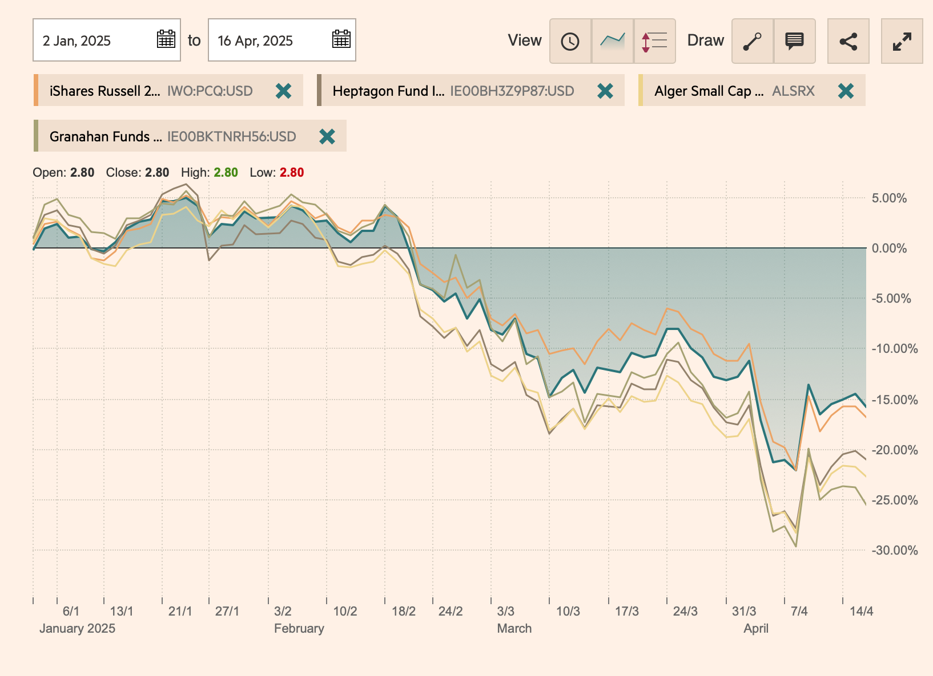
source: FT
What does the NCG US Small Cap Growth proposition offer?
25 year performance NCG versus Benchmark:
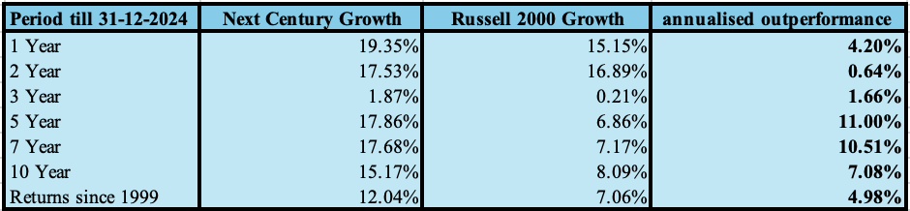
Monthly Returns from Jan 1999 to Dec 2024 displayed in US Dollar gross of fee.

Orchard US Small Cap Value Equities
Not strong YtD, but after 9.2% outperformance in 2024, YtD performance Orchard US Small Cap Value (green) art. 8 UCITS fund versus iShares Russell 2000 Value:
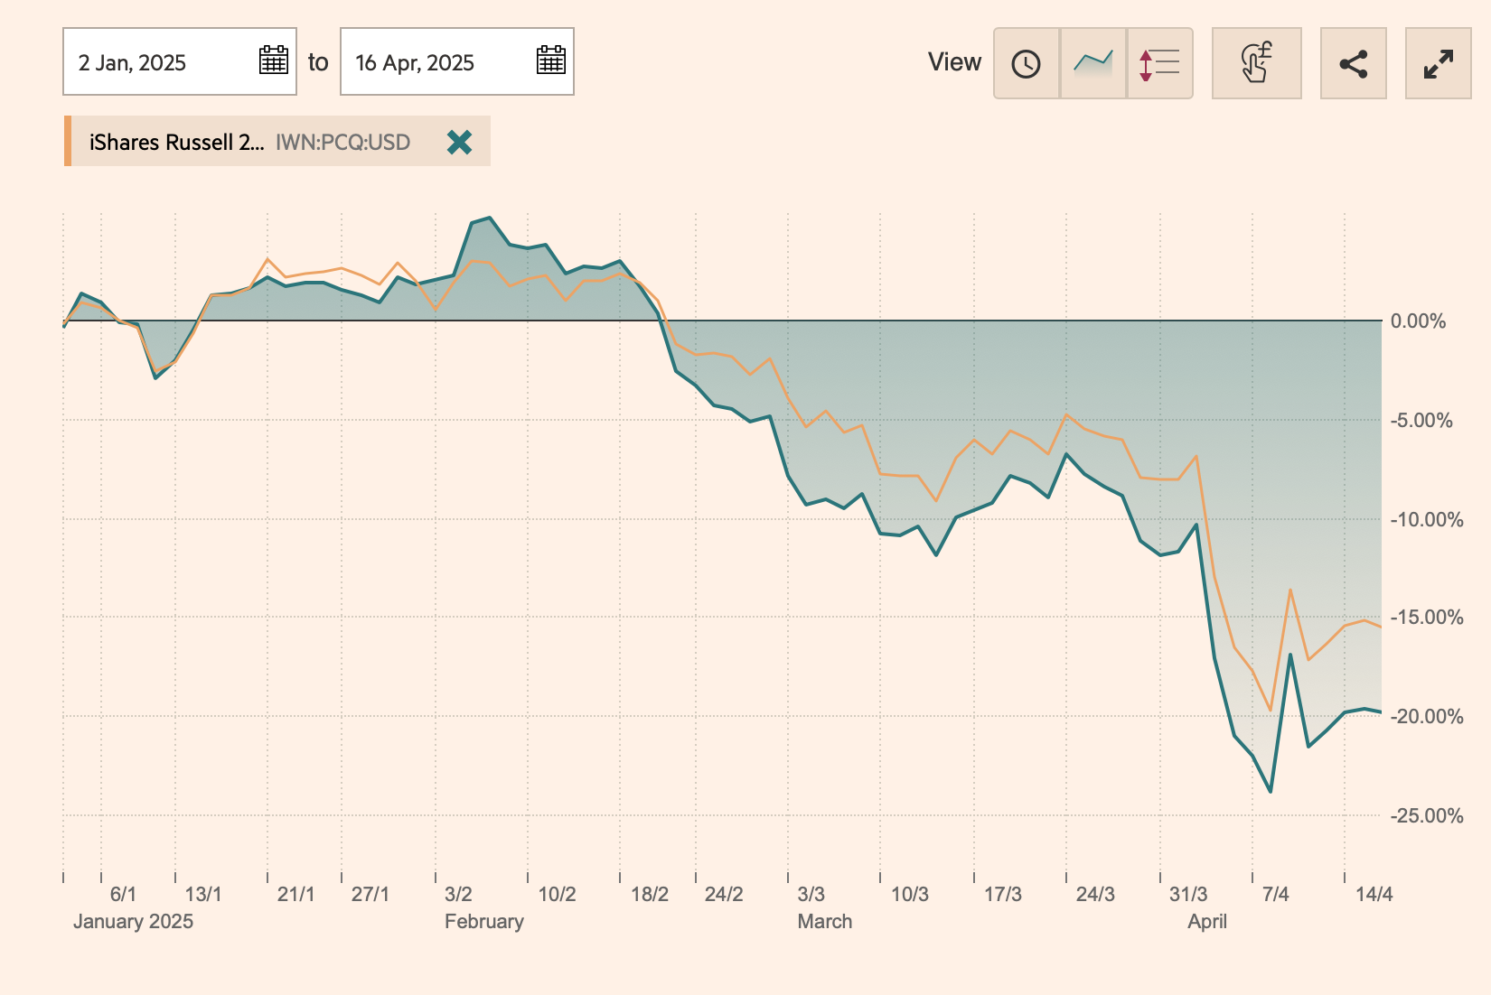
source: FT

DSM Growth Equity
DSM US Large Cap Growth YtD -0.4% vs the R1000G YtD
DSM Global Growth YtD -2.2% vs the MSCI ACWI Growth
DSM's Global and US Growth strategies have outperformed their benchmarks over multiple cycles:
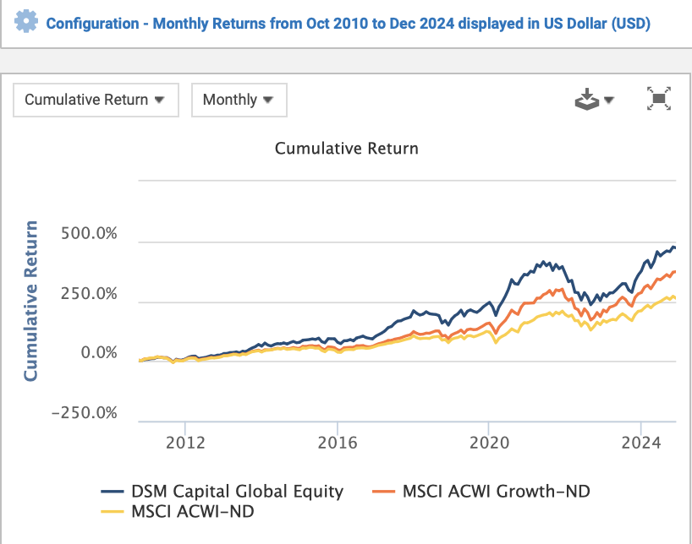

DSM US Large Cap Growth
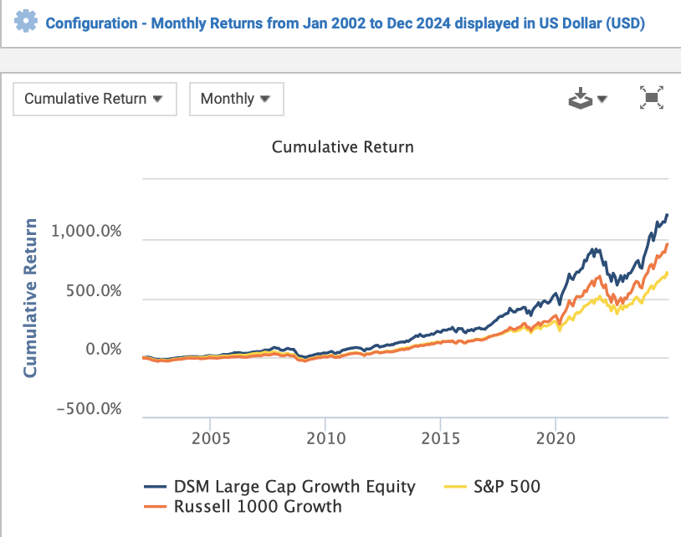

VanEck Emerging Market Debt
Winner of Best Emerging Market Bond Fund Europe on a 3 and 5y basis!
Refinitiv Lipper Fund Awards 2025
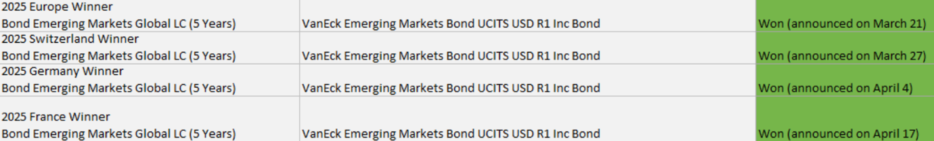
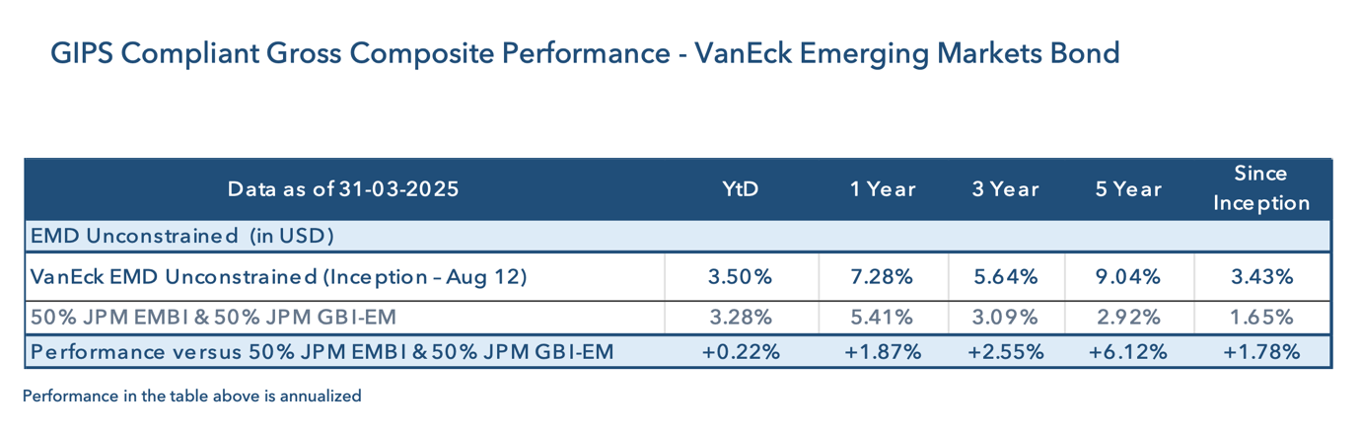

It is DM that is causing the trouble..
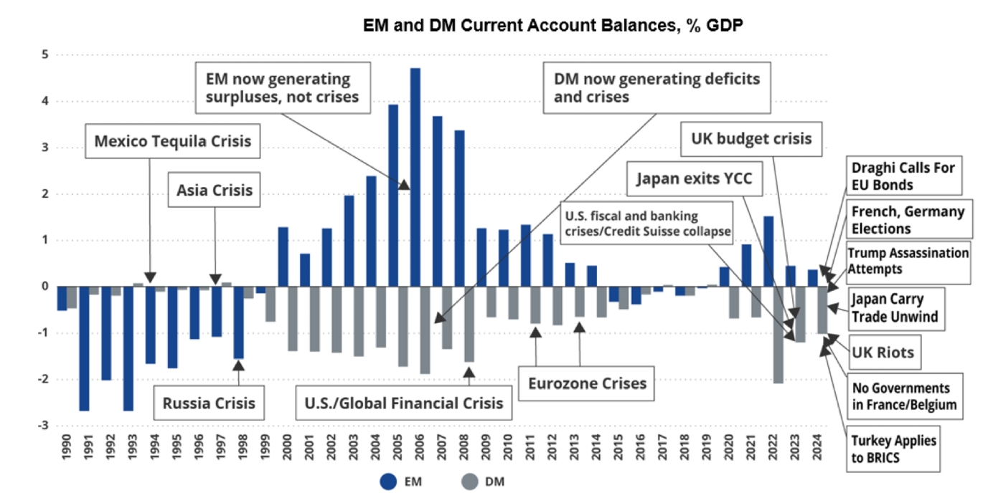

Not surprisingly given their debt levels
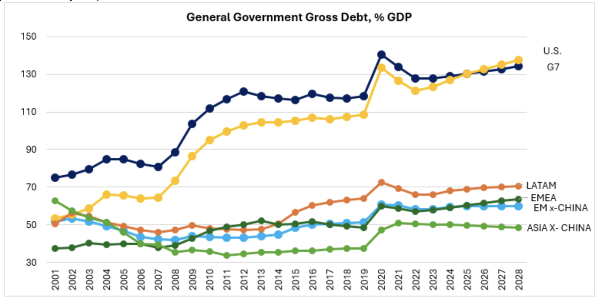

VanEck EMD Flexible Blend art. 8 UCITS fund:
- Higher Yield than Global High Yield with a higher average credit rating
- Truly flexible EMD strategy allocating to HC, LC and Corporates
- Quarterly distributing (paying out) shareclasses in USD and Euro hedged
- 4% annualised outperformance during last 5 years over the 50/50 HC/LC EMD Benchmark gross of fees
- With an ever increasing US deficit, Europe in trouble, why not diversify away to EMD and get a high yield (see below)?
- Attractive fees: Euro hedged I1 class is 55 bps management fee, the > 20 mln class is 45 bps.
* Reply to this email for more information*
To view a Presentation on why EMD, why Blend, why now and why VanEck? click here

The repeatable investment process explained in 5 bullet points:
- Start by generating a portfolio of HC, LC and Corporate bonds with the highest yields relative to their fundamentals.
- Remove or reduce weightings for bonds that appear undervalued for valid, underlying reasons.
- Apply rigorous portfolio construction rules to ensure diversification and manage risks effectively.
- Adjust the portfolio to maintain balance, prevent excessive risk exposure, and consistently outperform the benchmark.
- The final portfolio should yield more than the benchmark, allowing for occasional mistakes while still achieving superior returns.

EM bonds have better long term performance than DM bonds:
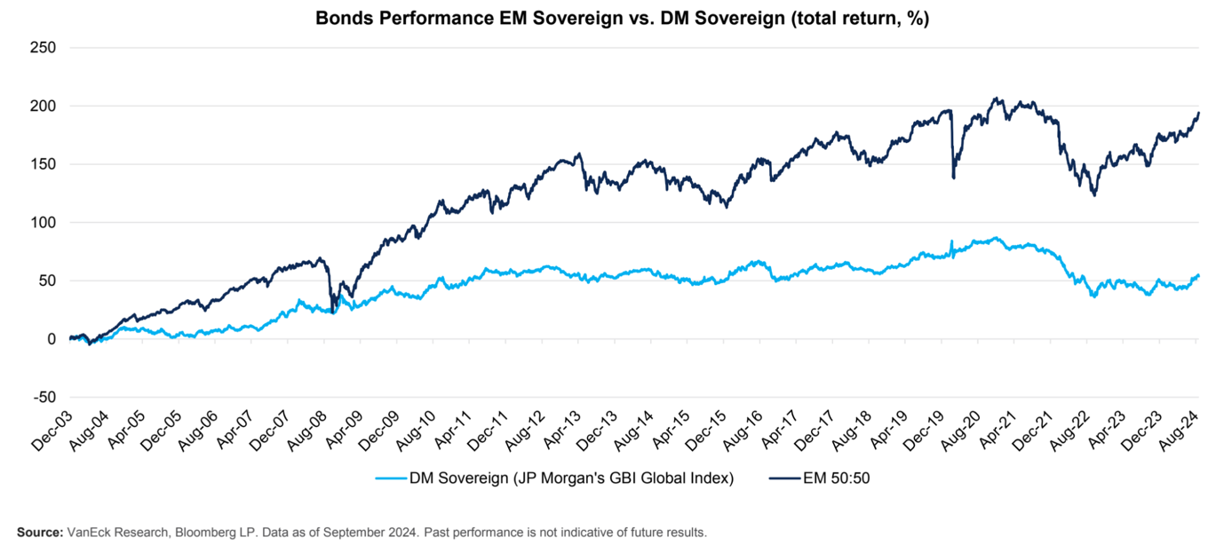

GSA Coral, Global Student Accommodation
Click here: For a 4 minute update video.
Student accommodation is a fast-growing sub-segment of real estate, driven by the global trend of increasing demand for education. Supply-demand imbalances create strong investment opportunities and the counter-cyclical nature offers a defensive risk profile. Leading operators, like GSA Coral, enjoy strong investment returns and pricing power.
Over USD 1 Billion is invested in the fund by European institutional investors.

Key features & fund strategy

- Most globally diversified student accommodation fund in the market
- Open-ended, monthly traded structure
- Balanced mix of operating assets (rental income returns) and development opportunities (enhanced capital growth)
- The Fund has cornerstone positions in joint ventures with major institutional partners
- Ongoing deep pipeline of acquisitions globally

More information?
- Presentation
- Factsheet
- Due Diligence Questionnaire
Or reply to this email to set up an online introduction/update

Click on the strategy name to subscribe or reply to this email. The updates are provided by the portfolio manager​​!​​​​​​
- 24 Apr at 15.00 CET, NCG US Small Cap Growth Update
- 8 May at 15.00 CET, VanEck Emerging Markets Debt Update
​​​​Upcoming trips with portfolio managers
We would be pleased to visit you, please email to candoris@candoris.nl to indicate your interest.
Summary strategies offered by Candoris:
Equities:
Letko Brosseau Emerging Markets Equity
Letko Brosseau is known for its long-term, value-oriented investment approach. They focus on identifying companies with strong fundamentals that are trading at attractive valuations relative to their intrinsic worth. The emerging market equity strategy involves rigorous in-house bottom-up research and analysis of individual companies supplemented with top-down analysis. A daily liquid Art. 8 UCITS fund with an AUM of USD 54.4 million is available. ISIN code: IE000LCBW880
As per Q1, 2025 the Letko Brosseau Emerging Markets Equity Strategy has an annualised outperformance of 3.58% over the MSCI Emerging Markets index, outperforming 96% of peers according to eVestment since inception in 2011. Letko Brosseau is an independent investment firm with a highly experienced investment team.
- Presentation
- Peer comparison
- Factsheet
- Standard RfP
- ESG Integration
- ESG Highlights Report
- Attribution Report and Commentary
- Replay Online Webinar
Lead Portfolio Manager Rohit Khuller

Bio Rohit Khuller of Letko Brosseau
​​​​

Next Century Growth US Small Cap Growth Equities
The Next Century Growth (NCG) US Small Cap Growth Strategy is a high conviction, high alpha generating strategy that seeks to invest in the fastest growing and highest quality small cap companies in America. A daily liquid Art. 8 UCITS fund with an AUM of USD 54.4 million is available. ISIN code: IE000TY23GV5
As per Q1, 2025 the Next Century Growth US Small Cap Growth Equity Strategy has an annualised outperformance of 4.82% over the Russell 2000 Growth index, outperforming 88% of peers according to eVestment since inception in 1999. Next Century Growth is an independent investment firm with a highly experienced investment team located in Minneapolis.
- Asset Class & Strategy Summary
- Presentation
- Peer comparison
- Factsheet
- Standard RfP
- Morningstar
- ESG Policy
- Sustainability Related Disclosures
- Replay Latest Online Update
Chairman, CEO, Portfolio Manager and Partner Thomas Press

Bio: Thomas Press of Next Century Growth Investors

Orchard US Small Cap Value Equities
The Orchard US Small Cap Value strategy is a high conviction, high alpha generating strategy that identifies companies that trade at a significant discount to where they should trade at and have one or multiple catalyst to unleash this intrinsic value. A daily liquid Art. 8 UCITS fund with an AUM of USD 132.7 million is available. ISIN code: IE00BL0L0092
As per Q1, 2025 the Orchard US Small Cap Value Equity strategy has an annualized outperformance of 2.2% over the Russell 2000 Value index since inception in 2001. Orchard Capital Management is a research-driven value investment manager solely focused on small cap value investing. As an independent employee owned boutique based in Chicago they deliver superior returns through proprietary research and a disciplined process. Long term US small cap value is the best performing segment of US Equities.
- Asset Class & Strategy Summary
- Presentation
- Peer comparison
- Factsheet
- Standard RfP
- Morningstar
- Orchard's approach to ESG
- Sustainability Related Disclosures
- Replay Latest Online Update
Founder and CIO Blake Harper

Bio: Blake Harper of Orchard Capital Management

​
DSM Growth Equity:
The DSM Growth strategies are high conviction strategies that invest in companies that have high earnings growth. A strict valuation discipline differentiates DSM from other growth managers. DSM capital manages USD 7.5 Billion in Equity strategies. DSM is an employee owned firm and employees invest their own private wealth alongside you as an investor.
DSM Global Growth
As per Q1, 2025 the Global Growth Equity strategy of DSM has an annualized outperformance of 1.32% over the MSCI ACWI Growth, outperforming 89% of peers according to eVestment since inception in 2010. A daily liquid Art. 8 UCITS fund is available with an AUM of USD 164.8 million. ISIN code: LU1016061043
- Asset Class & Strategy Summary
- Presentation
- Peer comparison
- Factsheet
- Standard RfP
- Morningstar
- Stewardship Report​​​​
- Sustainability Related Disclosures
- Replay Latest Online Update
- Artificial Intelligence (AI)
DSM US Large Cap Growth
As per Q1, 2025 the US Large Cap Growth Equity strategy of DSM has an annualized outperformance of 0.97% over the Russell 1000 Growth, outperforming 88% of peers according to eVestment since inception in 2002. A daily liquid Art. 8 UCITS fund is available with an AUM of USD 54.4 million. ISIN code: LU1440728472
- Asset Class & Strategy Summary
- Presentation
- Peer comparison
- Factsheet
- Standard RfP
- Morningstar
- Stewardship Report
- Sustainability Related Disclosures
- Replay Latest Online Update
- Artificial Intelligence (AI)
​​​
CIO Daniel Strickberger

Bio: CIO Daniel Strickberger of DSM Capital Partners

Coho ESG US Large Cap Equities
The Coho ESG Relative Value strategy is a true diversifier to most portfolios. Having a low down-market capture in combination with high quality holdings and strong ESG integration makes the strategy unique. It is one of the few US Value oriented ESG UCITS funds. A daily liquid Art. 8 UCITS fund with an AUM of USD 42.6 million is available. ISIN code: IE00BF1XKT19
As per Q1, 2025 the Coho Relative Value Equity (CRVE) strategy has an annualised outperformance of 1.63% over the Russell 1000 Value index. This strategy of quality companies with predictable streams of earnings offered protection during the IT crash in 2001, the financial crisis, the Euro crisis, during Covid-19 and in 2022. The strategy is fully invested without the use of derivatives. Coho Partners manages USD 4.1 billion in US Large Cap Equities, is an employee-owned firm and employees invest their own private wealth alongside you as an investor. The Coho ESG US Equity strategy (inception 2011) only deviates marginally from the original Coho Relative Value Equity strategy (inception 2000).
- Asset Class & Strategy Summary
- Presentation
- Peer comparison
- Factsheet
- Standard RfP
- Morningstar
- Impact Report
- Coho on ESG Investing
- Sustainability Related Disclosures
- Coho Cares

Founder and CIO of Coho Partners, Peter Thompson

Bio: Peter Thompson of Coho Partners

DSM Growth Equity:
The DSM Growth strategies are high conviction strategies that invest in companies that have high earnings growth. A strict valuation discipline differentiates DSM from other growth managers. DSM capital manages USD 7.5 Billion in Equity strategies. DSM is an employee owned firm and employees invest their own private wealth alongside you as an investor.
DSM Global Growth
As per Q1, 2025 the Global Growth Equity strategy of DSM has an annualized outperformance of 1.32% over the MSCI ACWI Growth, outperforming 89% of peers according to eVestment since inception in 2010. A daily liquid Art. 8 UCITS fund is available with an AUM of USD 164.8 million. ISIN code: LU1016061043
- Asset Class & Strategy Summary
- Presentation
- Peer comparison
- Factsheet
- Standard RfP
- Morningstar
- Stewardship Report​​​​
- Sustainability Related Disclosures
- Replay Latest Online Update
- Artificial Intelligence (AI)
DSM US Large Cap Growth
As per Q1, 2025 the US Large Cap Growth Equity strategy of DSM has an annualized outperformance of 0.97% over the Russell 1000 Growth, outperforming 88% of peers according to eVestment since inception in 2002. A daily liquid Art. 8 UCITS fund is available with an AUM of USD 54.4 million. ISIN code: LU1440728472
- Asset Class & Strategy Summary
- Presentation
- Peer comparison
- Factsheet
- Standard RfP
- Morningstar
- Stewardship Report
- Sustainability Related Disclosures
- Replay Latest Online Update
- Artificial Intelligence (AI)
​​​
CIO Daniel Strickberger
Bio: CIO Daniel Strickberger of DSM Capital Partners

Fixed Income:
Strategic income Management US High Yield Opportunities:
The SiM US HY strategy is a high conviction, high alpha generating strategy. The unique, pragmatic and counter-cyclical approach to investing in US HY has lead to superior returns with less risk (down-market capture 89.5%). SiM manages USD 2.8 billion in US HY only and a daily liquid Art. 8 UCITS fund is available with an AUM of USD 401.6 million: ISIN Code: IE00BF1XKP70
As per Q1, 2025 the Strategic income Management (SiM) US High Yield strategy has an annualized outperformance of 1.85% over the BofAML US High Yield index, outperforming all of peers according to eVestment since inception in 2011. A core portfolio around long term secular trends is complemented with out of favour sector and small cap issuer allocations. The team successfully employed the same investment strategy for more than 20 years. SiM is employee owned and employees invest their own private wealth alongside you as an investor.
- Asset C​​​​​lass & Strategy Summary
- Presentation
- Peer comparison
- Factsheet
- Standard RfP
- Morningstar
- Why US HY Presentation
- Sustainability Related Disclosures
- Replay Latest Online Update
- SiM and its investment process explained in 12 min
CIO and High Yield Portfolio manager Gary Pokrzywinski

Bio: Gary Pokrzywinski of Strategic investment Management

VanEck Emerging Market Debt:
The VanEck Emerging Markets Bond strategy is one of the few truly flexible EMD blend managers using the distinct risk and return characteristics of each of the three EMD sub universes (HC, LC, Corporates). A daily liquid Art. 8 UCITS fund is available with an AUM of USD 126 million: ISIN code: IE00BYXQSF37
As per Q1, 2025 the VanEck Emerging Markets Debt strategy has an annualized outperformance of 1.78% over the 50% JPM EMBI & 50% JPM GBI-EM benchmark, outperforming 67% of peers. A flexible approach is key to optimising portfolio risk/return using the distinct characteristics of each of the emerging markets debt sub-universes.
- Asset Class & Strategy Summary
- Presentation
- Peer comparison
- Factsheet
- Standard RfP
- Morningstar
- Sustainability Related Disclosures

Lead Portfolio manager Eric Fine

Bio: Eric Fine of VanEck

